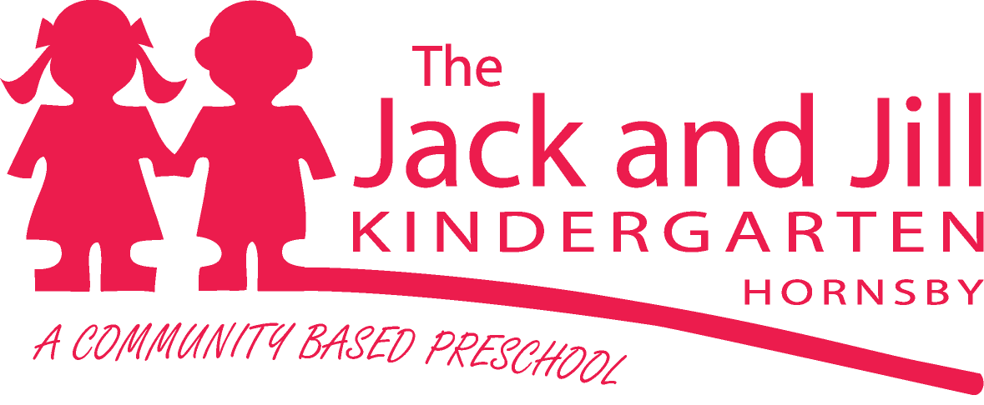
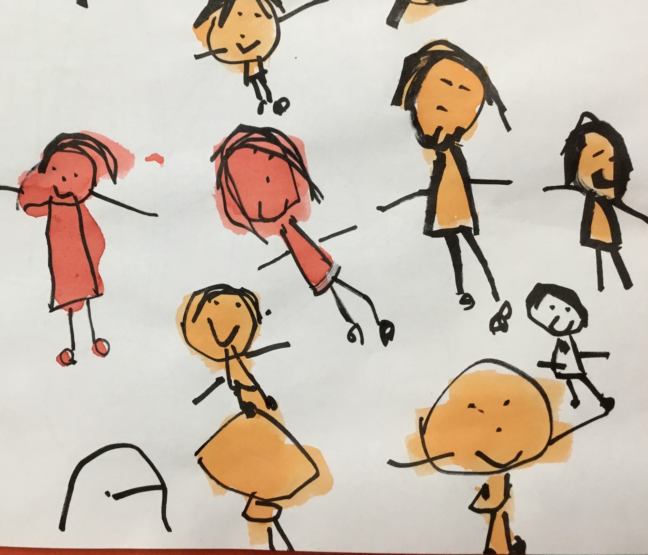
2019
1 Hall Road, Hornsby NSW 2077 Tel: 02 9477 3572
Email: administration@jackandjillkindergarten.com.au
www.jackandjillkindergarten.com.au
This booklet contains information about The Jack and Jill Kindergarten,
to help you understand more about our centre.

MISSION STATEMENT
The Jack and Jill Kindergarten aims to provide a foundation for learning, growing and developing in a warm, trusting and secure environment where the whole child is respected. It is our aim to provide experiences that are engaging and develop skills for lifelong learning. We work hard to make preschool a place of wonder and joy where learning is occurring all the time and through everything we do. We are a centre that promotes and encourages inclusion of all children regardless of ability, gender, language or culture.

OUR PHILOSOPHY
Our Centre philosophy is based on acceptance and is about providing an environment within which all children regardless of ability, gender, language or culture are equally valued. It is through this sense of inclusion that we are able to see children as capable and resourceful learners who need to be valued as individuals. We know that children develop confidence and positive self-esteem through a supportive and secure environment and that they learn through collaboration, communication with other children and adults and through interacting with the environment. We also realise positive mental wellbeing is as important as physical wellbeing.
We value family involvement. Trust, respect and collaboration form the basis for strong partnerships between families, children and staff. Parents and children need to be part of the decision making that takes place about the learning that occurs within our centre. Sharing knowledge and working in collaboration results in the best outcomes for children.
Our program is founded in play-based learning. A stimulating and nurturing environment promotes imagination, creativity and development and an engaging music program enhances children’s cognitive, physical, social and emotional development and communication skills.
We acknowledge the traditional owners of the land on which our preschool stands and aim to include Aboriginal culture and the 8 ways of Aboriginal learning into our program.
We strive to be a centre of excellence for early childhood education within our community. As advocates for our profession, it is important we share our knowledge and experience. We understand the needs of children, families, staff and the community are constantly changing, and that ongoing evaluation is essential to create a service that is responsive to those needs.
From this philosophy we have developed many policies, which provide guidelines for the operation of our centre. Policy review and development is ongoing.

OUR PROGRAM – PLAY BASED LEARNING
Here at The Jack and Jill Kindergarten we work to a play based program. This means our daily routine includes;
- active indoor and outdoor play
- Integration of music, movement and creative expression
- Adult-child interactions that help foster play and social interactions
One of the greatest benefits of play is to assist with the development of social competence. Children can build relationships, learn to resolve conflicts, negotiate and regulate their behaviours. In play, children usually have increased feelings of success and optimism as they act as their own agents and make their own choices. Play is a known stress release, it is often linked to child wellbeing.
The dispositions for learning, such as curiosity, openness, optimism, resilience, concentration, and creativity (SACSA, 2009), are developed in play. Play is linked to the development of resilience and the beginnings of empathy as children begin to understand other points of view.
Everything we do here has a purpose and staff give great thought to the activities that are offered to the children. We take time to get to know your child and base our decisions for programming based on our understanding of your child within our classroom.
We do not teach the children to read or write in an academic sense, however they will learn these skills and many more through play.

HOURS OF OPERATION
Our hours are 8.30am to 4.00 pm, Monday to Friday. The preschool operates during NSW School Terms and is closed during school holidays and on public holidays. The preschool presently offers positions on a 2 or 3 days per week basis.
The office is open on Monday, Tuesday, Wednesday and Friday mornings, from 8.30 am to 1.00 pm for administrative enquiries.

STAFF
Nominated Supervisor & Inclusion Support Teacher:
Mrs Pearl Sachinwalla (B. Ed Early Childhood)
Teachers:
Mrs Jin Park (Master Special Ed. Early Childhood Teacher)
Ms Linda Lin (B. Teach Early Childhood)
Educators:
Miss Karen Fenwick (Dip of Community Services in Child Care)
Mrs Kathy Norris (Cert III in Children’s Services)
Mrs Neda Alipourfard (Cert III in Children’s Services)
Mrs Karen Khatiz (Cert III in Children’s Services)
Office Administrator:
Mrs Lisa Larkins (Cert III Business Administration)

FEES

Administration Fee for Waiting List: $30.00 (inc GST)
Enrolment deposit $200.00 advance fees
(this is refundable in your child’s last term of preschool, however is not refundable if you do not proceed with enrolment)
Daily Attendance Fee
Children eligible for school in 2019 (birth date on/before 31/07/2015): $49.00 a day (may be reduced with Start Strong Funding of up to $15 a day)
Low income families/Aboriginal, Torres Strait Islander background: $29.00*(may be reduced with Start Strong Funding of up to $15 a day)
All other children: $59.00 a day (may be reduced with Start Strong Funding of up to $15 a day)
Maintenance Levy (refundable via our Parent Participation Program): $200.00 ($100 paid in term 1 and $100.00 paid in term 3)
Social Levy $60.00 (inc GST)
Centre Membership Fees $6.00 joining fee (inc GST)
$6.00 annual subscription (inc GST)
Please note:
* Fee relief is available for eligible families with a low-income Health Care Card/Pension card or of Aboriginal, Torres Strait Islander background. An application will accompany enrolment forms. Applications can also be made throughout the year should family circumstances change.
Payments are due in Week 2 of each term. Any queries should be directed to the Nominated Supervisor: Pearl, or our Administrator: Lisa
Payment methods accepted for fees are:
Cheque (personal or bank cheque are both acceptable)
Internet Banking – details available on the bottom left hand corner of your invoice.
NO CASH PLEASE
If you have any queries at all regarding our centre fee structure and/or payment methods, please speak to Pearl (Nominated Supervisor) or Lisa (Office Administrator).
The Jack and Jill Kindergarten is a not-for-profit organisation that exists only with the support and co-operation of every family whose children attend. We aim to keep our fees as low as possible, but to do so we need your assistance.

PARENT INVOLVEMENT
There are many opportunities for you to be involved in the preschool program. You will be invited to many social events both during the day and in the evening. You can volunteer to spend a morning in the classroom being involved in the morning activities, or you may be available to join us for one of our incursions. The children love to see their families at preschool, but please discuss your intention to visit with your teacher first.
We welcome parents’ and carers’ comments or concerns in any area, and encourage you to speak with us if you have any concerns or comments that may help us improve Jack and Jill.

THE MANAGEMENT COMMITTEE
Management of The Jack and Jill Kindergarten is carried out by a Committee elected each year at the Annual General Meeting (AGM).
The Committee is comprised of the President, Vice President, Treasurer, Secretary, Social/Fundraising Convenors, Maintenance Officer and general members. Some of the Committee also serve as directors of The Jack and Jill Kindergarten.
Committee members hold office for 12 months and meet at least twice a term with the Nominated Supervisor and a staff member, to make decisions regarding management of the centre.

THE SOCIAL/FUNDRAISING COMMITTEE
The Social/Fundraising Committee has an important role in keeping fees low and connecting families with each other. The Committee provides the opportunity for families to participate in social activities such as family discos, Mother’s and Father’s Day events, etc.

CENTRE MAINTENANCE
During the year, parents are asked to participate in maintaining the centre and its equipment. This ensures that the environment is safe and secure for children.
Maintenance tasks include:
- Weekend working bees, held twice a term, to keep the grounds and equipment maintained;
- toy cleans during terms 2 and 4, on weekday mornings, to keep equipment hygienically safe;
- volunteering to assist at social events;
- towel cleaning rosters;
- take home jobs, e.g. sewing, book covering, washing dress-up clothes and repairs

The maintenance levy of $200.00 per family payable at the commencement of Terms 1 and 3 is refundable at the end of Terms 2 and 4 provided that maintenance tasks are completed.
The levy is run as a 200 point system, where the above maintenance tasks are allocated a points value. Essentially 1 point = $1 of refund. You must complete 200 points to receive your full refund. You can sign up for tasks throughout the year or ask our Office Administrator (Lisa) for assistance.
You will receive more information regarding our Parent Participation Program at the beginning of your child’s enrolled year.
If your family chooses not participate in centre maintenance, the levy is forfeited and that money will be used to assist with the preschool’s maintenance.

OUR DAY
Our routine varies slightly each term however as a general overview this is what will happen throughout the day;
- On arrival children wash their hands, put their lunch in the fridge and greet the staff. Parents ensure their child is signed in
- Indoor play (morning and afternoon)– a selection of activities is available for the children to play with, teachers and educators are actively involved in play with the children, guiding and developing social skills, fine motor skills, problem solving and language.
- Outdoor play (morning and afternoon)- a selection of activities is available for the children to play with, teachers and educators provide a range of both active and passive outdoor activities
- Morning tea – the children eat together and are encouraged to try new foods, develop good eating habits and manners
- Singing – each day both classes come together for singing. This is a very special part of our day and we value music education very highly. The children learn a huge range of songs and this helps with language development, listening skills and working together as part of a group
- Group time (morning and afternoon) – the children sit and participate in a large group activity. This includes listening to a story, having a class discussion, music and movement games etc.
- Lunch time – the children sit together at lunch this is an opportunity to promote healthy eating, develop social skills and enjoy each other’s company. Staff eat with the children.
- Rest time – we have a rest after lunch, the children do not have to sleep but we help them learn how to calm themselves and relax. This is a very important skill in our busy world.
- When leaving, children wash their hands before going home. Parents ensure their child is signed out.

WHAT TO BRING TO PRESCHOOL

For Morning tea:
In Terms 1 and 4, bring a piece of fruit from home. The fruit is cut at the centre and shared between the children;
In Terms 2 and 3, Jack and Jill provide cut sandwiches;
In Term 4, a snack may be brought from home when given notice by staff, to prepare the children for morning tea at school.

Lunch:
A packed lunch and a bottle of water. Please send a healthy and nutritious lunch, and leave cakes, roll-ups, sweets, chocolates and biscuits at home;

Also pack:
- A spare set of clothes, pants and socks (for unforeseen accidents);
- A small towel (with a loop sewn on) to hang in your child’s locker;
- A fitted sheet and a flat sheet for rest time (cot size);
- A broad-brimmed sun hat – No caps please
All belongings must be clearly labeled with your child’s name.

Please note:
- Children are provided with waterproof aprons for painting, etc.
- Children should wear enclosed shoes, for safety. No thongs or “crocs” allowed.
- Children should wear clothes they can handle easily to achieve independent dressing and toileting skills.
- It is advisable to discourage your child from bringing toys from home, as they may become broken or lost, and we have many at the centre.

ON YOUR ARRIVAL AND DEPARTURE
- Please greet a staff member each morning and afternoon. All children need to be brought into the centre and collected from the centre by a responsible adult (Over 18 years old).
- Should you wish another person to collect your child, you must first sign a “Consent to Collect” form and give this to your child’s teacher. We must have a signed form prior to releasing a child into the care of an adult other than their legal carer. NO CHILD LEAVES THE CENTRE WITHOUT THEIR PARENTS PERMISSION. If the person collecting your child is unfamiliar to us we will ask to take a copy of their identification (e.g. Drivers Licence).
- Children must be signed in and out of the centre each day. Each class has a sign-in book by the door.
- A late fee of $50/hr (charged at $12.50 per 15 minute interval) is payable if your child is collected after 4:00 pm.

LOCKERS
Each child is allocated a locker. All your child’s belongings must be collected and taken home at the end of each weekly visit (including their hat and sheet bag).

SIGNING IN AND OUT
A record of attendance is kept by law. All parents/carers must sign and specify the time of their child’s arrival and departure at the centre.

NOTICES AND ACCOUNTS
Notices, accounts etc. that applies to your family will either be placed in the pocket, above the sign-in book, with the number corresponding to your child’s locker or emailed to your nominated email address. Please check your communication pocket each morning and afternoon as you sign your child in and out.
Please ensure an up-to-date email address has been included on your enrolment forms and please advise Katrina of any changes to this. You will also have access to Educa – our online site which acts as a snapshot to your child’s day and updates on our Preschool. A weekly newsletter “The Kindy Crier” is sent out on Fridays with preschool and community news and events.
We also notify parents of upcoming events and activities by means of posters and notices in and around the locker room. Please take time to read all notices.

BIRTHDAYS
If you would like us to celebrate your child’s birthday, please provide cupcakes (or similar) as close to the date of your child’s birthday as possible. As each child in the centre is given a cake, we will need 40 and we ask that they be taken to Karen in the kitchen on your arrival in the morning. Cakes are sent home in lunch boxes for afternoon tea. (Children with special diets will need to supply an alternative).

INCURSIONS
Shows and incursions are an important part of the preschool program, whether a puppet show or a science experience. We will notify you well in advance of any proposed events, and we welcome full parent participation. We do ask that younger siblings not attend, as the shows are geared for preschoolers.

CHRISTMAS CONCERT
A Christmas concert is held for each group of children in December each year, where the children sing and dance for a family audience. The preschool day finishes at 12.30 pm on concert days, immediately following Christmas lunch at the centre.

BEHAVIOUR MANAGEMENT
Staff use a positive approach to behaviour guidance, the aim being to encourage children to follow centre routines, while enhancing their self esteem and encouraging them to interact positively with their peers.
Staff understand that behaviour is just another form of communication. We will work with the child and their family to understand why they may be struggling and how we can help them. Children are also encouraged to participate in the setting of simple rules to follow within the centre, and the children tell each other how to behave properly. Staff will encourage children to show empathy for children experiencing difficulty.

Some rules we ask children to remember:
- We walk down the path and on the concrete.
- We always walk inside.
- We listen when someone else is talking.
- We care for each other and take turns and share.
- Trees, gardens, toys, books and equipment are cared for.
- Sand belongs in the sandpit.
- We look after our own belongings.
These rules exist so that we can provide a secure, caring and safe environment that will enhance each child’s growth and development.

HEALTH AND SAFETY
Staff are alert to the health and safety of each child in attendance at the centre.
- Please ensure that your contact details are current on your child’s enrolment.
- Gates must be kept shut.

There is always a qualified First Aid Officer in attendance on staff at the premises.
We also have a regularly maintained, well stocked first aid kit for use at the centre.

There is an emergency plan in case of accidents and centre evacuation.
All parents/carers’ will be notified or emergency contact(s) contacted.
The centre keeps a record of all accidents and emergency evacuations.
All serious incidents will be reported to the relevant authority (ACECQA)

NUTRITION
The staff must ensure that the food provided at the centre is within good nutrition guidelines. Chips, sweets, chocolate and cake are not within the guidelines.
If your child has special dietary needs, these requirements must be specified on your child’s enrolment.
Please Note: We are an allergy-conscious centre; therefore we have a policy that ensures the centre is nut-aware. We may from time to time put in place other initiatives to meet needs made known to us, so please make known to the Nominated Supervisor (Pearl) any allergy requirements for your child. Please be mindful when providing snacks, as some store-purchased snacks may contain nut products.
At mealtimes, staff will check that all children’s hands are washed before they eat or drink.

SICKNESS
If your child is sick and unable to attend, please notify the centre before 9.00 am. Most importantly, the Nominated/Certified Supervisor must be promptly informed of infectious diseases.
We regret that we are unable to provide the special care required by a sick child.
No doubt you understand that infections spread very quickly in groups.
We ask you to keep your child at home if they have:
Temperature, diarrhea, severe skin rash or infection, diphtheria, measles, rubella, head lice, excessive discharge from the eyes, ears or nose, conjunctivitis, chicken pox, infectious hepatitis, mumps, cold sores, ringworm, impetigo (scabby sores), whooping cough, heavy cold or persistent cough.
(See our policy book for more details or ask staff about exclusion periods).
Should your child become unwell during the day, we will phone to ask the child’s parent or carer or emergency contact person to collect the child immediately from the centre and complete and sign an illness form.
Please note: The Nominated/Certified Supervisor reserves the right to send home a child if they feel that the child is unfit to remain. This is to protect the interests of all children and staff at the centre.

MEDICATION
Staff are unable to administer medication without your authority. A medication consent form is required and is available from Karen in the kitchen. Please hand over any medication to staff. DO NOT leave medication in your child’s locker. When the medication is due, two members of staff will administer and sign off. Please note: ALL medication and allergy notifications must be authorised by a medical practitioner and be provided in their originally dispensed containers and be within the expiry date.

TOILET TRAINING
Parents and carers are encouraged to toilet train their child prior to attending. We do not have nappy changing facilities at the centre or the staff ratios to accommodate regular nappy changing.

IMMUNISATION
Under the Public Health Act, the director of a child care facility must request parents to provide a record of their child’s immunisation status at the time of enrolment.

SUN CARE AND PROTECTION POLICY
The program incorporates sun and skin protection awareness. The staff ensures all children apply sunscreen and wear hats for all outdoor activities. We supply sunscreen for application in the morning by parents.

SUPPLIES REQUIRED
To help keep fees low, requests are sent out to each family from time to time to provide supplies, such as tissues, paper towels and toilet paper.

STUDENTS AND VOLUNTEERS
We encourage and support the involvement of students and volunteers interested in gaining experience in the early childhood field.
The Nominated Supervisor will oversee their participation in the program and establish arrangements with the centre.

GRIEVANCES
If parents or carers have any grievances or concerns, the procedure is as follows:
- Talk with your child’s teacher. If you feel that avenue has been unsuccessful then;
- Speak with the Nominated Supervisor (Pearl). At this stage you can opt to fill in a Grievance Form if you would like the matter documented;
- If the matter cannot be resolved, your next step is to take your grievance to the Committee, either by way of a letter, or by discussing it with an Executive Committee member. Please see Lisa in the office for Executive Committee contact details; and
- If you are still dissatisfied with the outcome, you are also able to take your grievance ACECQA 1800619113
If you require any information or assistance, please feel free to speak with the appropriate staff member.

Thank you for taking the time to read this booklet.
(Amended on 12/11/18)
Cover Artwork by Avina 2018

